July 29, 2016 HeadShop 9.2 WIN

While HeadShop was well received, there were some issues that I want to address with a free upgrade, HS 9.2. Work on PrintAhead is very well suited and will improve HeadShop.

Here is what we will include in HS 9.2

**New Set-up process: ($100)**

Exactly like the PA 2.0 set-up, with one more addition.

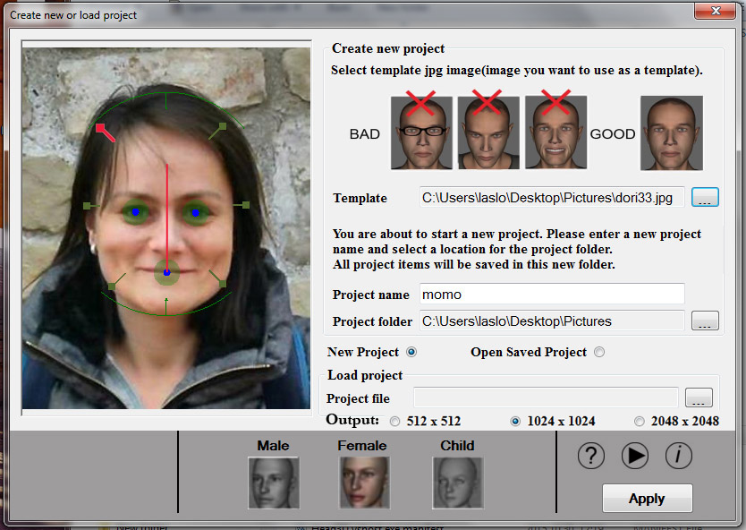

People seem to overlook that the headshape dots need to be moved. Also, since they are moved one-by-one, asymmetry can happen. To address these, we need to make:

1. The dots flash on the left side and flash until touched or moved.
2. The corresponding right dot needs to move symmetrically equal distance form center. This way user only need to move 3 dots instead of 6 and head will be symmetrical.

**Addition of little picture to profile dialog ($25)**

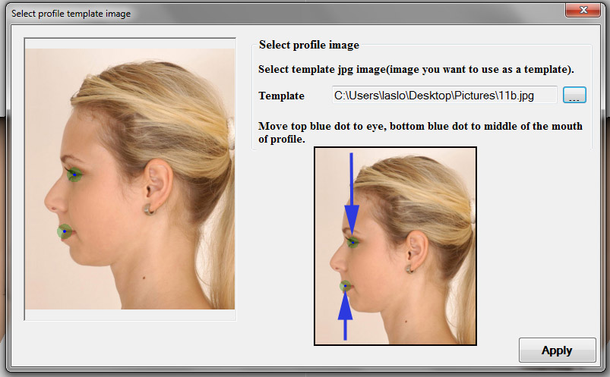

**Neck and Head will automatically pick up color ($50)**

Same as PA 2.0

